Vietnam, China, and the United States regarding the maritime territorial disputes in the South China Sea
In recent years, the South China Sea has become an invaluable and coveted territory to those who border it: China, Malaysia, Brunei, Singapore, the Philippines, Taiwan, and Vietnam (Taiwan will also be referred to as a “state” for the duration of this paper). These sovereign states and other regional states primarily covet these waters for its rich fishing grounds, rich gas and oil reserves, and key maritime trade routes.
These maritime territorial disputes have existed for centuries, but after China placed an oil rig in disputed waters 80 nautical miles from Vietnam’s coast in May 2014, states along the South China Sea erupted and catalyzed retaliations throughout the entire region. Since May 2014, the states involved have been testing territorial boundaries and the patience of neighboring states with flyovers, patrols, warnings, threats, drills, and diversions.

The Disputes in Light of UNCLOS
These South China Sea territorial disputes are complicated due to the number of states involved and historical claims. They all presume their rights are in accordance with the 1982 United Nations Convention on the Law of the Sea (UNCLOS), which ensures economic, intellectual, ecological, national, and personal security and rights worldwide. The Law of Nations and Territorial Sea Conventions are examples of other international agreements that are written to ensure many of the same securities and rights worldwide. Other regional countries are outraged over China’s continuous actions, which they believe violate multiple articles of UNCLOS regarding freedom of the high seas, including Article 89 which directly states “No State may validly purport to subject any part of the high seas to its sovereignty.” China has restated claims to about 90% of the South China Sea as its exclusive economic zone, which supposedly holds much of the oil and gas reserves.
China is also staking its claim in the South China Sea by building its own islands in the Spratly archipelago. [See map and photo in Appendix] This is arguably illegal under Article 121 of UNCLOS which states “An island is a naturally formed area of land...,” but China disregards this and says they are simply building in a region that is already theirs. These rapidly constructed manmade islands—now developed with possible high-frequency radar capabilities, piers, and a completed 10,000 foot airstrip—are currently drawing the world’s attention and are seen by a majority as threatening. Data show all nations in the South China Sea region increasing their military defense capabilities.
China and its regional neighbors have signed many multilateral and bilateral treaties regarding territories and regional cooperation in the past 20 years, including the December 1999 Treaty on the Land Border China signed with Vietnam. These treaties—like many—are not always fulfilled or followed through.

Vietnam and China
Vietnam is the most involved in countering China’s claims in the South China Sea. Rooted in globalization, Vietnam’s relations with the United States, China and its other regional neighbors have undergone stark changes in the past decades. Before 1975 Vietnam outwardly supported China’s claims in the South China Sea to; until China approached the Parcel Islands a few months before Vietnams’ victory against America. The short yet scarring Sino-Vietnamese wars of 1974, 1979, and 1988 resulted in developing heavy mistrust between two countries in a region that is known to remember past conflicts and enemies.
Sino-Vietnamese tensions have escalated to a point where China and Vietnam are on the brink of a major military crisis, and some say war. China’s percentage change in military spending increased 167% from 2005 to 2014. Vietnam’s military spending correspondingly increased 170%. The next highest increase was 30% by the Philippines; and they are also beginning to compete more economically. Vietnam has rapidly expanded economically with exports now accounting for 86% of its GDP, most of which goes to the United States—China’s major economic partner.

Vietnam and China: Paracel and Spratly Islands
Both the Paracel and Spratly Islands have been claimed by both China and Vietnam and have been the staging grounds for many recent Sino-Vietnamese conflicts. [Reference map in Appendix for island groups’ respective locations.] Vietnam claims that their islands are part of its continental shelf zones and Established Economic Zone (EEZ) while China holds to their occupation of the Parcels from Vietnam in 1974.
China’s first armed-conflict over the Spratlys occurred on 14 March 1988 when its navy sank three Vietnamese vessels and killed 74 Vietnamese sailors.
Since 1999 China has unilaterally declared a ban on fishing for several weeks a year in the northern part of the South China Sea for the sake of repopulation. Since Vietnam does not recognize the ban and continues to fish, Chinese patrol ships arrest hundreds of Vietnamese fishermen every year in an attempt to assert control over the Parcels region.
In May 2014, the Chinese state placed an oil rig in disputed waters 80 nautical miles from Vietnam’s coast, causing China and Vietnam to send patrols and warships to the area. After a 75-day standoff, a Vietnamese ship was sunken by a Chinese warship, triggering intense anti-China protests in Hanoi and elsewhere. With aid from emerging partners, Vietnam has been expanding its military along its Chinese border and its naval forces. Vietnam’s goal of their military buildup is to “deter its giant northern neighbor as tensions rise over the disputed South China Sea.”
In January 2016, the Chinese government deployed a “civilian aircraft” to test their new man-made Fiery Cross Reef airport in the Spratly archipelago. Hanoi formally describes this incident as a serious, illegal infraction to their own sovereignty and demanded China not commit such an act again. China’s foreign ministry spokesperson Hua Chunying retorted that “China has indisputable sovereignty over the Nansha Islands [the Chinese name for the Spratly archipelago] and their adjacent waters. China will not accept the unfounded accusation.” Both countries are unwavering in their claims and statements, especially when countering the other’s statement.

Vietnam and Regional Allies
As a result of its recent rise and the conflict in the South China Sea, Vietnam has been soliciting regional partners that share its concerns regarding China’s regional dominance. Regional allies have sided with Vietnam in protesting against China’s military tests and reclamations of land, including Japan who defended that the action did not help in forming a peaceful settlement and was a wrong move by the Chinese government. A strategic gathering of the Association of Southeast Asian Nations (ASEAN) states could prove to be very fruitful. Vietnam is in the process of constructing partnerships with Japan and the Philippines in particular because they are U.S. allies and generally influential in the region. They have increased arms trade with Russia, India and Israel, including aid in weapons, training and intelligence exchange. Vietnamese Prime Minister Nguyen Tan Dung stated “Vietnam will do what it can to join other regional countries in consolidating peace and stability in the region;” Vietnam is not sitting idle.

The Disputes and the United States.
So where does the United States stand in the South China Sea maritime territorial disputes? It could alienate itself, but interests such as regional influence, economic stability, global peace and Southeast Asian partnerships cause intervention to be the more likely stance. As of January 2016, there are no capable China-Vietnam regional mediators. This leaves the United States—a.k.a. the “world police”—as a likely impartial mediator to defuse tensions, construct terms of agreement between China, Vietnam and ASEAN, and help the region dodge serious conflict using both its soft and hard power.
However, the U.S. does not seem to be impartial; it has already shown strong signs of support for Vietnam, even at the cost of angering China. Throughout last year, the U.S. challenged China’s claims in the waters, deploying a guided missile destroyer, surveillance planes and a warship near China’s claimed reefs; actions which resulted in multiple warnings from Beijing. After the January 2016 dispute, the U.S. State Department formally stated that China should halt all land reclamation and militarization in these waters. Many individuals in Washington suspect that China’s artificial islands in the South China Sea were created for military purposes; a claim that Beijing denies. After a flyby last December, China accused the U.S. of “serious military provocation” and demanded that Washington desist from any more negative provocations. This incident seemed to reinvigorate China’s reclamations.
Nations bordering the South China Sea—like Vietnam—seem to be willing and perhaps able to defend their interests against China. Alexander Bernard and Paul Leaf strongly contend that the United States should focus on continuing to expand its bilateral relationship with Vietnam as a key military and economic ally. This effort has already begun, supported by President Barack Obama’s visit to Hanoi in November, 2015. Chinese Premier Xi Jinping also visited Hanoi last November, exposing an uncomfortable tension between the countries. The U.S. could expand defense agreements and aid with Vietnam, which require bilateral agreement and compromise. One issue the U.S. has with Vietnam is their human rights problems, to which they need to seem indifferent.

Conclusion
The maritime territorial disputes in the South China Sea will not be resolved swiftly or easily. There are news reports almost every day about the region: China testing air flights on their man-made islands; China training “fishing militia;” Japan providing Vietnam and the Philippines with coastal patrol boats; and multiple nations—including the U.S.—conducting military exercises, patrols and flyovers. It will be very interesting to see what happens next and note which countries decide to participate in what way. The topic of the South China Sea territorial disputes—and the inter-nation relations therein—merit deep academic attention and is due to mark an important point in Southeast Asian History.
Bibliography
"Beijing Sea Flight Test on Disputed Island Draws Rebukes from US, Neighbors.” DW. Deutsche Welle, January 5, 2016. Accessed April 26, 2016.
Bernard, Alexander, and Paul J. Leaf. "Why the United States and Vietnam Urgently Need to Deepen Ties." The National Interest, September 11, 2015. Accessed April 22, 2016.
Catley, Bob and Makmur Keliat. Spratlys: The Dispute in the South China Sea. (Brookfield: Athenaeum Press, 1997).
“China’s Maritime Disputes: A CFR InfoGuide Presentation.” CFR. Council on Foreign Relations. Accessed April 28, 2016.
“Chinese military plane makes first public landing on disputed South China Sea island.” ABC. ABC News, April 16, 2016. Accessed April 26, 2016.
Fawchett, J.E.S. The Law of Nations. (New York: Basic Books, 1968).
Fergus, Ryan. "South China Sea: US Bomber Angers Beijing with Spratly Islands Flypast." The Guardian. December 18, 2015. Accessed April 27, 2016.
Hunt, Katie, and Kevin Wang. "Vietnam Protests Chinese Test Flight in South China Sea - CNN.com." CNN. Cable News Network, January 4, 2016. Accessed April 26, 2016.
Jakobson, Linda, and Bonnie Glaser, “South China Sea: Conflicting Claims and Tensions,” Lowy Institute for International Policy, October 2015, accessed April 26, 2016.
Kurlantzick, Joshua. "A China-Vietnam Military Clash: Contingency Planning Memorandum No. 26." Council on Foreign Relations. September 2015. Accessed April 25, 2016.
Ngo, Di Lan. "Vietnam Between China and the United States: The Next Balancing Test Beckons." The Diplomat. October 16, 2015. Accessed April 26, 2016.
Overlapping Claims -- How the South China Sea Is Divided. 2016. CNN. Comp. Asian Maritime Transparency Initiative and UNCLOS. Web. 5 Jan. 2016.
Rajagopalan, Megha. “China trains ‘fishing militia’ to sail into disputed waters.” Reuters. April 30, 2016. Accessed May 1, 2016.
Robson, Seth. “Japan should join US efforts in South China Sea, defense expert says.” Stars and Stripes, March 10, 2016. Accessed April 26, 2016.
Roy, Denny. Return of the Dragon: Rising China and Regional Security. (New York: Columbia, 2013).
SarDesai, D.R. Vietnam: The Struggle for National Identity. (San Francisco: Westview, 1992).
Shinkman, Paul D. "Vietnam: From War Zone to the Belle of the Ball." U.S. News & World Report. November 5, 2015. Accessed April 26, 2016.
Simmons, Kenneth R. U.N. Convention on the Law of the Sea 1982. (New York: Oceana Publications, 1983).
Torode, Greg. "Vietnam Builds Military Muscle to Face China." Reuters UK. December 18, 2016. Accessed April 27, 2016.
"US Opposes China Runway Test on Reef; Echoes PH, Vietnam Protest." The Inquirer. January 5, 2016. Accessed April 26, 2016.
“Vietnam-China row over South China Sea plane landing.” BBC News. January 3, 2016. Accessed April 26, 2016.
"Vietnam Protests after China Lands Plane on Disputed Spratly Islands." The Guardian. Reuters, January 3, 2016. Accessed April 28, 2016.
Watkins, Derek. “What China Has Been Building in the South China Sea.” New York Times. February 29, 2016. Accessed April 27, 2016.
Zou, Keyuan and Shicun Wu. Non-Traditional Security Issues and the South China Sea: Shaping a New Framework for Cooperation (Burlington: Ashgate, 2014).
Appendix
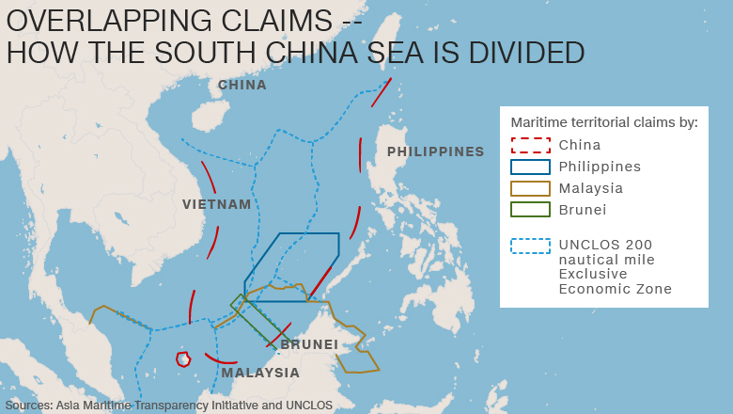
2016. <http://www.cnn.com/2016/01/03/asia/china-vietnam-south-china-sea/>.

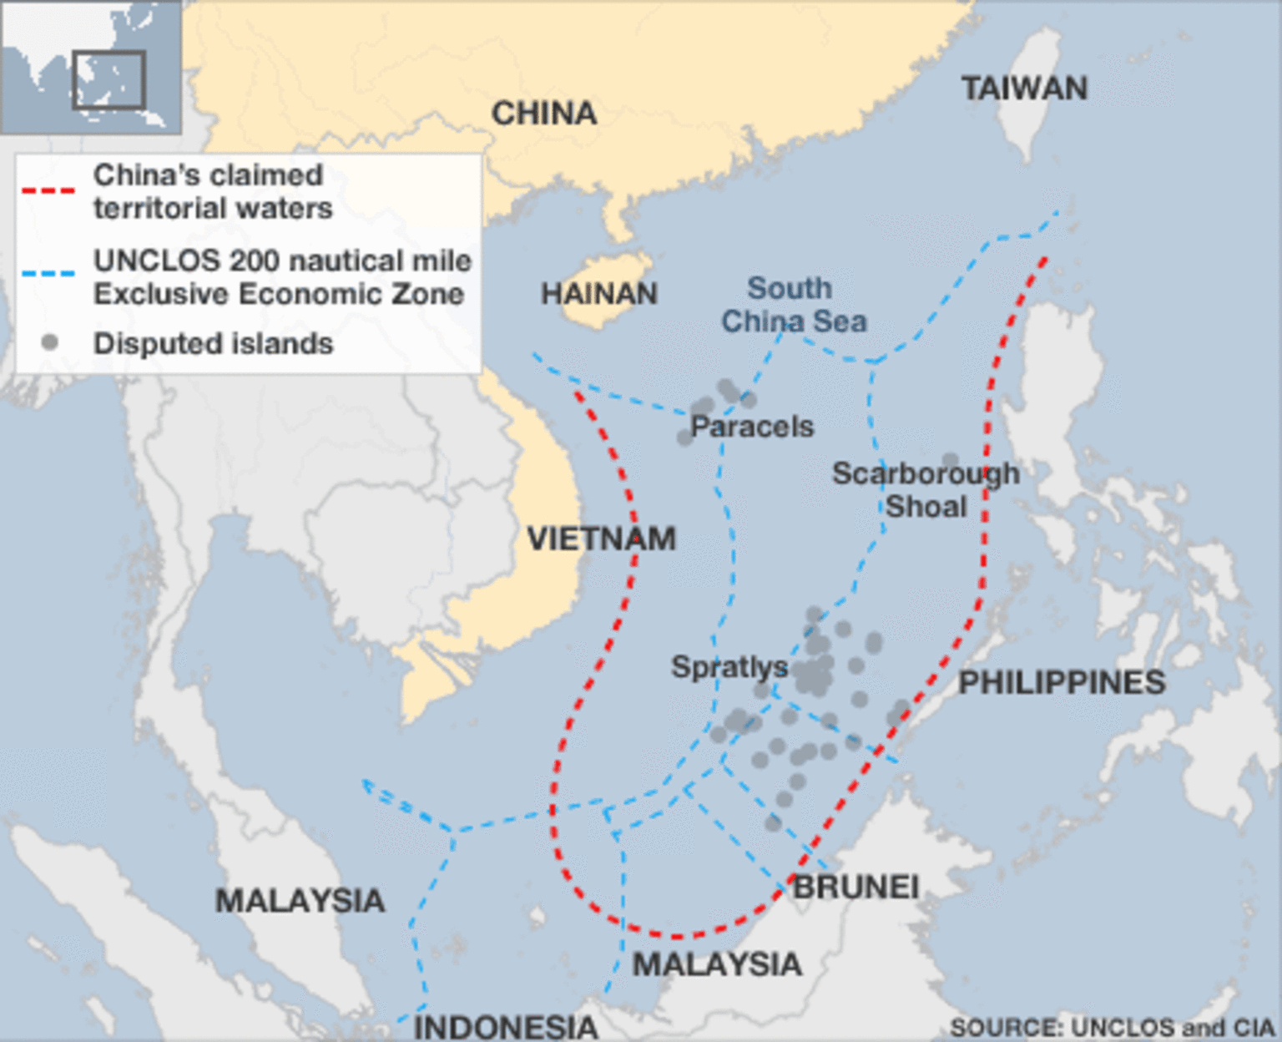
2015. <http://www.bbc.com/news/world-asia-pacific-13748349>
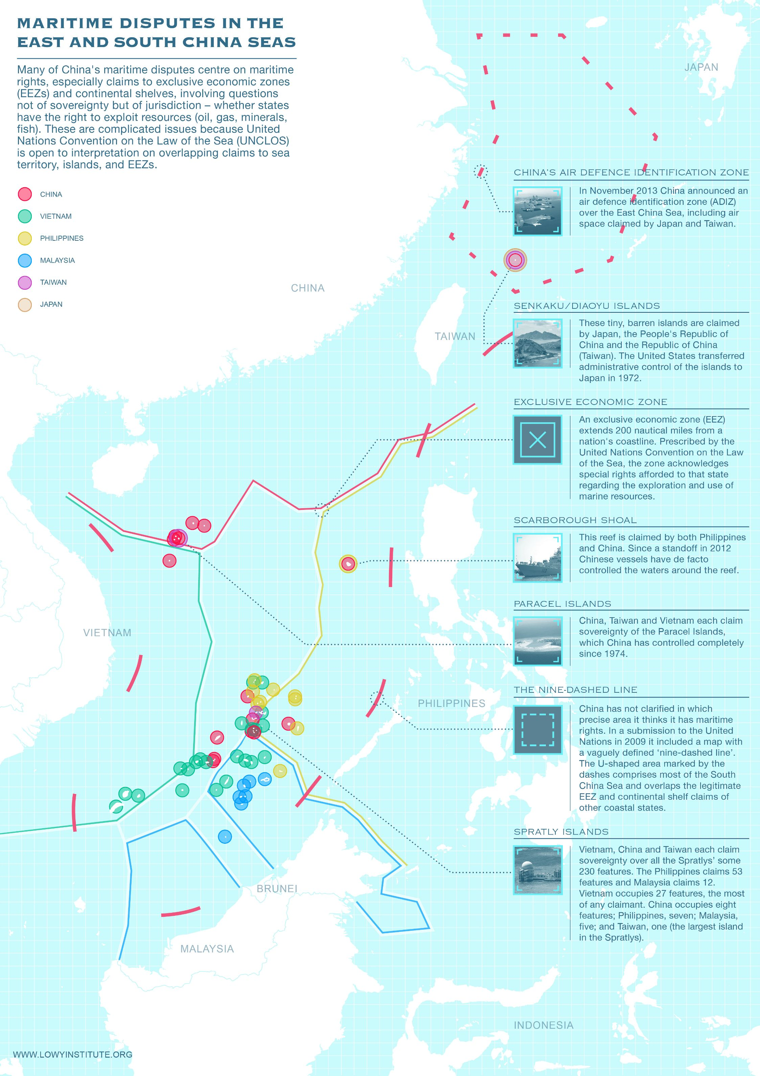
2016. <http://www.lowyinstitute.org/issues/south-china-sea>.
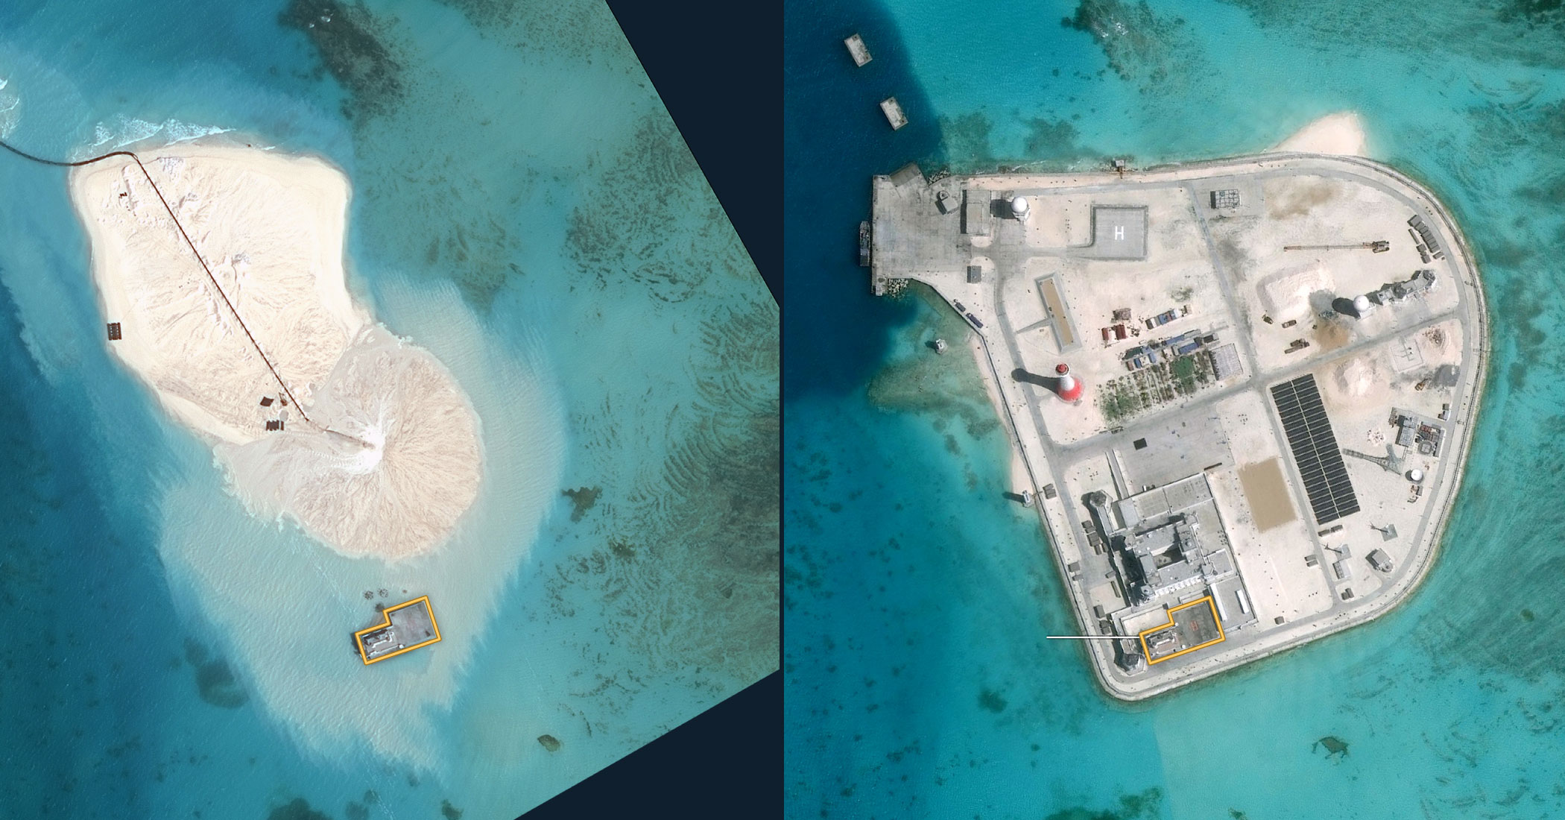
2016. <http://www.bbc.com/news/world-asia-pacific-13748349>
“Construction on Johnson South Reef from January 2014 to February 2016.

Paul D. Shinkman, "Vietnam: From War Zone to the Belle of the Ball," U.S. News & World Report, November 5, 2015, accessed April 26 2016.
Keyuan Zou and Shicun Wu, Non-Traditional Security Issues and the South China Sea: Shaping a New Framework for Cooperation (Burlington: Ashgate, 2014).
Kenneth R. Simmons, U.N. Convention on the Law of the Sea 1982 (New York: Oceana Publications, 1983).
Ibid., B62.
Joshua Kurlantzick, "A China-Vietnam Military Clash: Contingency Planning Memorandum No. 26," CFR, September 2015, accessed April 25, 2016.
Derek Watkins, “What China Has Been Building in the South China Sea,” New York Times, February 29, 2016, accessed April 27, 2016.
Simmons, B72.
Watkins, “What China Hass Been Building.”
Zou and Wu, Non-Traditional Security Issues and the South China Sea, 90.
Bob Catley and Makmur Keliat, Spratlys: The Dispute in the South China Sea (Brookfield: Athenaeum Press, 1997): 92-98.
Shinkman, “Vietnam: From War Zone to the Belle of the Ball.”
Linda Jakobson and Bonnie Glaser, “South China Sea: Conflicting Claims and Tensions,” Lowy Institute for International Policy, October 2015, accessed April 26, 2016.
D.R. SarDesai, Vietnam: The Struggle for National Identity (San Francisco: Westview, 1992).
“China’s Maritime Disputes,” CFR; Roy, 227.
Denny Roy, Return of the Dragon: Rising China and Regional Security (New York: Columbia, 2013): 118-120.
Shinkman, “Vietnam: From War Zone to the Belle of the Ball.”
Greg Torode, "Vietnam Builds Military Muscle to Face China," Reuters UK, December 18, 2016, accessed April 27, 2016.
Katie Hunt and Kevin Wang, "Vietnam Protests Chinese Test Flight in South China Sea," CNN, January 4, 2016, accessed April 26, 2016; "Vietnam Protests after China Lands Plane on Disputed Spratly Islands," The Guardian, Reuters, January 3, 2016, accessed April 28, 2016.
“Vietnam-China row over South China Sea plane landing,” BBC News, January 3, 2016, accessed April 26, 2016.
Hunt and Wang, “Vietnam Protests”; “Vietnam-China row over South China Sea plane landing,” BBC News.
Torode, "Vietnam Builds Military Muscle to Face China.”
“China’s Maritime Disputes,” CFR.
"Beijing Sea Flight Test on Disputed Island Draws Rebukes from US, Neighbors,” DW. Deutsche Welle, January 5, 2016, accessed April 26, 2016; Hunt and Wang, “Vietnam Protests.”
"US Opposes China Runway Test on Reef; Echoes PH, Vietnam Protest," The Inquirer, January 5, 2016, accessed April 26, 2016.
Ryan Fergus, "South China Sea: US Bomber Angers Beijing with Spratly Islands Flypast," The Guardian, December 18, 2015, accessed April 27, 2016.
Alexander Bernard and Paul J. Leaf, "Why the United States and Vietnam Urgently Need to Deepen Ties," The National Interest, September 11, 2015, accessed April 22, 2016.
Di Lan Ngo, "Vietnam Between China and the United States: The Next Balancing Test Beckons," The Diplomat, October 16, 2015, accessed April 26, 2016.
Ibid.; Bernard and Leaf, “Why the United States and Vietnam.”
“Chinese military plane makes first public landing on disputed South China Sea island,” ABC, ABC News, April 16, 2016, accessed April 26, 2016.
Megha Rajagopalan, “China trains ‘fishing militia’ to sail into disputed waters,” Reuters, April 30, 2016, accessed May 1, 2016.
Seth Robson. “Japan should join US efforts in South China Sea, defense expert says,” Stars and Stripes, March 10, 2016, accessed April 26, 2016.

